**INSIGHTS FROM LOK SABHA ELECTION RESULTS**

1. The top 5 parties that won the most seats are:

* BJP(303), CONGRESS(52), DMK(23), RYTHU CONGRESS(22), ALL INDIA TRINAMOOL CONGRESS(22)

1. The correlation between Won and Percentage of won is:

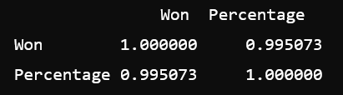

1. The most average seats won by the party are 303(BJP) and least is 1 seat and BJP has highest percentage of votes which is 44.2%.
2. BJP is the party that won the elections with the highest percentage.
3. A Horizontal bar chart is used to focus on the total seats won by the regional parties.
4. The spread and distribution of the seats won by different parties is given by the box plot.
5. Heatmap highlights the correlation between “Won”, “Leading” and “Total Seats” which uncovers the underlying patterns.
6. A Scatter plot illustrates the relationship between seats won and leading for each party.
7. Used bar chart to represent the percentage of total seats won by each party to highlight the party dominance.
8. Most of the parties fall within a percentage range of 4% to 44%, this shows variation in voter support.